融合报道、应用创新参评作品推荐表

作品标题 | 一“宇”道破丨新疆“强迫劳动”的谎言是怎么编造出来的？ |  |  | 参评项目 | 国际传播（融合报道）
主创人员 | 徐泽宇 |  |  | 编辑 | 集体（张正富、高杉、田子骏、李泽欣）
原创单位 | 新华通讯社 |  |  | 发布平台 | 新华社客户端
发布日期 | 2022年6月20日21时34分
作品链接  和二维码 | 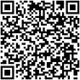  https://h.xinhuaxmt.com/vh512/share/10894421?d=1348acc&channel=weixin
作品简介  （采编过程） | 美国所谓“维吾尔强迫劳动预防法”生效前夕，新华社徐泽宇工作室制作播发英文舆论斗争短片《新疆“强迫劳动”的谎言是怎么编造出来的？》，追溯“强迫劳动”谬论的炮制过程，曝光美西方编造涉疆谎言的关系网络，揭露美国涉疆恶法毫无依据的事实本质。短片以资料搜集、学理论证、证据重组作为基础，建构出一套逻辑严密、事实充足、条理清晰的叙事体系，在西方主流涉疆叙事中打开了一个突破口。短片在新华社客户端浏览量超100万，在海外社交媒体平台播发后总浏览量达到245万。
社会效果 | 《新疆“强迫劳动”的谎言是怎么编造出来的？》短片在新华社海媒主账号、徐泽宇海媒个人账号播发后在国际舆论场产生了巨大影响力。视频吸引了大量海内外媒体、学者、政府官员、知名大V进行点赞留言转发，并纷纷批驳美国涉疆立法的做法，其中包括：外交部发言人汪文斌、英国前议员George Galloway、今日俄罗斯资深记者Tom Fowdy、美国作家Jim Hanson、美国经济学教授Asatar Bair、澳大利亚媒体人Jerry Grey、美国国际关系学者Mark Sleboda等。澳大利亚学者Tim Anderson转发视频后留言称：“就涉华议题而言，我从此以后只相信北京发布的消息，来自华盛顿的言论就算了吧。”加拿大媒体人Daniel Dumbrill在推特上向本片制作人徐泽宇发送私信表示：“你做的揭批郑国恩的视频非常棒，证据翔实、逻辑清晰，把新疆‘强迫劳动’谣言的来龙去脉彻底分析清楚了。
初评评语  （推荐理由） | 本条短片制作精良、逻辑新颖、视效突出，在涉疆议题上进行了有效的话语创新，在海外产生了积极传播效果。  签名：  （加盖单位公章）  2023年 月 日
联系人 | 徐泽宇 | 邮箱 | xuzeyuphilip@gmail.com |  |  | 手机 | 15801359170
地址 | 北京市西城区宣武门西大街57号 |  |  |  |  | 邮编 | 100803
1.《一“宇”道破丨新疆“强迫劳动”的谎言是怎么编造出来的？》二维码

2.《一“宇”道破丨新疆“强迫劳动”的谎言是怎么编造出来的？》首页首屏截图
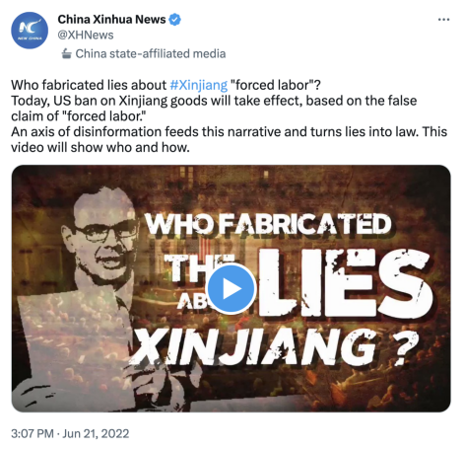
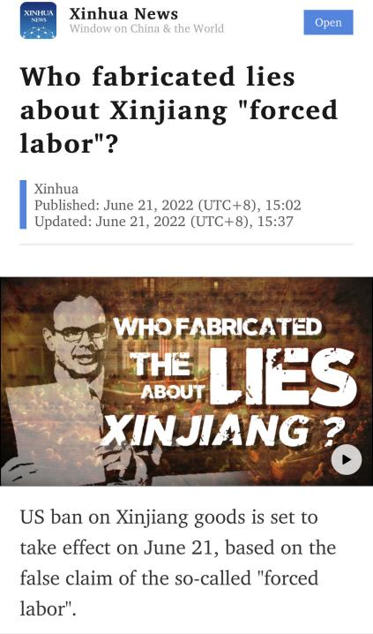
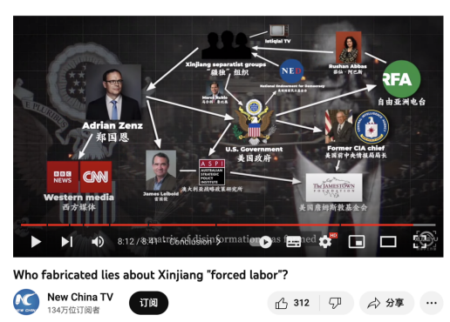
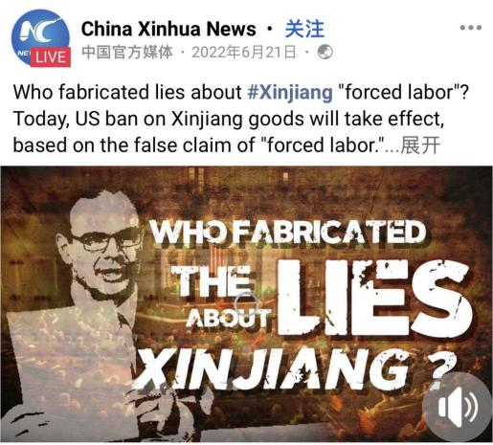

3.《一“宇”道破丨新疆“强迫劳动”的谎言是怎么编造出来的？》英文原文和中文倒译
US ban on Xinjiang goods is set to take effect on June 21, based on the false claim of the so-called "forced labor".
美国涉疆法案将在今年6月21日生效，制定这个法案的借口就是新疆出现所谓“强迫劳动”的现象。
However, the law enabling this ban actually came from a lie.
然而，这实际上源自一个谎言。
This video will showcase who fabricated the lie about Xinjiang "forced labor", and how it affected US legislation.
这个短片将向你揭秘，到底是谁在编造新疆“强迫劳动”的谎言，而这个谎言又是如何影响美国立法程序的。

4.《一“宇”道破丨新疆“强迫劳动”的谎言是怎么编造出来的？》视频内容中英文文字稿

【旁白】
自6月21日起，美国政府将对来自中国新疆的商品实施禁令。新疆棉花产量占全球20%，多晶硅产能占全球近一半。这条禁令无疑将严重干扰全球产业链。
Starting June 21, the US government is set to ban imports of goods coming from China's Xinjiang.
As China’s largest region, Xinjiang produces 20% of world’s cotton and accounts for half of global production of the raw material for semiconductors.
This ban is likely to plunge global supply chains into further chaos.
【出镜】
尽管蒙着一层“保护人权”的面纱，这条禁令背后的法案却源自一个粗制滥造的谎言。Despite all the high-minded rhetoric on human rights, the law enabling this ban actually came a long way from a piece of poorly produced fiction.
【旁白】
那么，谎言是如何成为法律的呢？
So, how did a lie become law?
让我们首先看看这个法律制定的依据是什么。美国提出这个所谓“维吾尔强迫劳动预防法案”的核心理由是新疆存在“强迫劳动”。议案称有新疆遭受“关押”和“强迫劳动”的人数有180万。
First, let’s take a look at the cause for this legislation.
The so-called “Uyghur Forced Labor Prevention Act” was prompted by the claim that there was "forced labor" in Xinjiang.
It was so bold to claim that the number of people in Xinjiang subject to “arbitrary detention” and “forced labor” was estimated to be 1.8 million.
这个数字是从哪里来的？
But where did this number come from?
【旁白】
一个叫郑国恩的人扮演了关键角色。郑国恩（Adrian Zenz）是隶属于一个右翼基金会的学者，只作为游客来过一次新疆，但这并不妨碍他成为频频登上西方媒体的“新疆问题专家”。他在2018年发表的涉疆报告首次提出“新疆有100万人被拘押”，这个数字很快就写进了2019年开启立法程序的美国“维吾尔人权法案”中。当郑国恩在2019年11月出炉的新报告里将数字“上调”到180万之后，180万这个新数字又出现在了2020年开启立法程序的美国“维吾尔强迫劳动预防法案”。
A man named Adrian Zenz played a key role.
Zenz is a so-called researcher from Germany. He has close ties to ultra-rightist groups. And he has only been to Xinjiang once as a tourist. But it didn't seem to hurt his reputation as a “Xinjiang expert” on Western media.
In 2018, Zenz was among the first to claim that the total number of detainees in Xinjiang might reach "over one million". The number "one million" soon paraded into the legislative process of the US "Uyghur Human Rights Policy Act" that started in early 2019.
And after Zenz casually upped the number to 1.8 million in his 2019 report, the new figure almost immediately found its way into the bills that later shaped to be the so-called “Uyghur Forced Labor Prevention Act”
【旁白】
郑国恩是怎么得出这些数字的呢？
But how did Zenz come up with those numbers?
他在2018年的报告中提出新疆“有几十万到一百万人被拘禁”。其中最有力的“证据”来自于一篇日文报道，这篇日文报道援引了一个叫Istiqlal TV的“疆独”宣传组织，称“维吾尔收容所关押89万人”。也就是说，郑国恩使用了一个源自“疆独”分子的三手消息来论证“新疆有100万人被拘押”，而这个未经证实的说法迅速登上了西方各大主流媒体的头条，蓬佩奥甚至用这个说法来指控中国“种族灭绝”。
The number “one million” first surfaced in Zenz's report in 2018.
Curiously, Zenz's groundbreaking finding was attributed to a story in Japanese. And this story in turn cited this figure "890,000" which was cobbled together by a Xinjiang separatist outlet named Istiqlal TV.
That is to say, a fishy third-hand account was packaged into Zenz's study to prove the validity of mass detention. But this shady finding soon hogged the news headlines.
And Zenz's claim even prompted Mike Pompeo to play fast and loose with the genocidal accusation on China.
【旁白】
既然这次美国通过的法案声称要预防“强迫劳动”，那么郑国恩又是如何证明新疆存在“强迫劳动”的呢？
Since the US "Xinjiang embargo" is allegedly designed to prevent “forced labor”, then how did Zenz prove the existence of “forced labor” in Xinjiang in the first place?
郑国恩在一篇中文论文里发现，新疆跨地区劳动力转移就业有“下乡宣传引导”和“自愿参与”的区别，所以他就认定这两种方式分别指的是“强制”和“非强制”，从而把中文语境里的“鼓励就业”曲解成了“强迫劳动”。郑国恩还宣称，“维吾尔族工人由政府人员和安保人员强制看管”。但当我们查询相关信息源就会发现，郑国恩引用只不过是中国地方政府就业部门的公告，里面从来没有提到安保人员，而且明确说明政府人员提供的是“服务”。
Zenz made a "major discovery" in an online Chinese essay. The essay claims that when it comes to Xinjiang's cross-region labor transfer, there are two sets of approach known respectively as “to inform and guide those in rural area”and “voluntary participation.” Zenz therefore assumed the first approach was supposed to be the opposite of "voluntary", hence "mandatory." In this way, Zenz successfully misrepresented what in Chinese context means "motivating people to get employed" as "forcing labor to displace."
Another key evidence for "forced labor" Zenz produced was the claim that the Uygur ethnic workers are subject to the custody of the "government minders" and "dedicated security personnel." However, if we trace down the source Zenz quoted, there was no mention of "security personnel" in the original Chinese text. And the government employees were only tasked to provide "service" to Uygur ethnic workers.
【出镜】
郑国恩在报告里不断放大和利用中英文转换过程中的误差，这些支离破碎的信息就成了美国涉疆立法的“事实基础”。
This is how Zenz profited from these discrepancies during Chinese-to-English translation, and painted them as evidence of "human rights violation".
【旁白】
通过这些“强迫劳动”证据的索引，我们也发现了究竟是谁在配合郑国恩玩这种文字游戏的。
Following the footnotes of these twisted interpretations, we also discovered who on earth helped Zenz pull the trick of Lost in Translation.
ASPI，澳大利亚战略政策研究所，长期进行反华宣传。去年，ASPI资金收入的近十分之一来自美国国防部，被用于所谓“新疆人权问题”的研究。在郑国恩刚刚改头换面成为“新疆问题专家”的时候，ASPI研究员雷国俊（James Leibold）就与郑国恩合署发表了多篇涉疆文章。雷国俊也自称是“中国问题专家”。这几篇文章发表的地方是美国詹姆斯敦基金会（Jamestown Foundation）的刊物，而这个组织又恰巧是由美国前中情局局长William J. Casey成立的极端保守派智库。也就是说，郑国恩借助美国政府资助的学者，在美国政府资助的刊物上编造关于新疆的谎言。
ASPI, Australian Strategic Policy Institute, which is famous for fomenting anti-China hysteria. Last year, 1/10 of ASPI’s revenue were earmarked by the US Department of Defense for the so-called “Xinjiang human rights” studies.
Even before Zenz was hailed by Western media as the "go-to person on anything Xinjiang", Zenz had already co-authored his early pieces on Xinjiang with an ASPI researcher named James Leibold, another self-vaunted "China expert."
Those publications were released mainly by the Jamestown Foundation, an ultra-conservative think tank founded by former CIA chief. In other words, Zenz fabricated a web of lies about Xinjiang with the help of the US-funded academics and the US-funded platforms.
【出镜】
即便如此，郑国恩的“新疆研究”从学术角度来看仍然是完全经不起推敲的。那么他究竟是如何影响西方主流舆论，进而影响美国立法的呢？
Still, Adrian Zenz's "Xinjiang study" could turn out totally unconvincing once carefully examined. Then how come it later shaped the Western public perception of Xinjiang and went so far as to affect the US legislation?
【旁白】
这就要提到一个叫做“自由亚洲电台”（RFA）的组织了。在很长一段时间，自由亚洲电台往往会第一时间发布郑国恩的涉疆“研究”和言论。当我们在自由亚洲电台网站里检索“郑国恩”，会发现它出来的结果比“布林肯”还多。自由亚洲电台反复宣传郑国恩，让“新疆存在强迫劳动”之类的论调向主流舆论渗透。自由亚洲电台对外宣称自己是独立的媒体机构，但是在美国去年通过的“2021年战略竞争法案”中明确写明，给自由亚洲电台拨款2000万美元，并要求美国政府增加对自由亚洲电台普通话、藏语、维吾尔语和粤语服务的资助。这个法案专门要求美国政府支持自由亚洲电台关于中国新疆的报道。
This is when Radio Free Asia, or RFA, came into the picture.
For a long time, this US-government-funded propaganda organ has been on the vanguard that publicizes Zenz’s latest “findings” on Xinjiang. A simple internal search of the name “Adrian Zenz” on RFA website would even yield couple dozens more results than that of “Antony Blinken”, the incumbent US Secretary of State. Through such repetitious publication, RFA allows "forced labor" theory and other fringe notions about Xinjiang to be picked up by the mainstream.
RFA has kept insisting its independence as a media outlet. But the US "Strategic Competition Act of 2021" has clearly outlined a plan to prop up its China-related language services by the way of over 20 million US dollars in funding. The Act cited RFA's Xinjiang coverage as a justification for that decision.
【旁白】
然而，自由亚洲电台的这些频道都有复杂的政治背景。茹仙·阿巴斯（Rushan Abbas）是自由亚洲电台维吾尔语频道的第一位记者。她在2017年创立了得到美国国家民主基金会（NED）资助的新疆分裂主义组织。2020年，茹仙·阿巴斯还在美国联邦参议员马克·卢比奥的邀请下参加了特朗普的国情咨文演说，而这个马克·卢比奥就是“维吾尔强迫劳动预防法案”的主要提案者。
RFA’s connections in the US politics goes even further. Rushan Abbas, for example, was the first correspondent in RFA Uygur Service. In 2017, she founded "Campaign for Uyghurs," a Xinjiang separatist group based in Washington. This organization was funded by US National Endowment for Democracy. In 2020, Abbas even attended Donald Trump’s State of the Union Address at the invitation of Senator Marco Rubio, who happens to be a major sponsor of the so-called “Uyghur Forced Labor Prevention Act”.
【旁白】
自由亚洲电台让郑国恩声名“大振”，他也终于获得了西方主流媒体的注意。英国广播电台（BBC）主动出资邀请郑国恩进行新疆问题“研究”，郑国恩自豪地表示他交出了一份“有17000字和163个脚注的报告”。显然，西方媒体并没有对这些文字和脚注进行过认真的核实，而是将郑国恩的荒谬结论传遍了世界，一遍、一遍、又一遍地传播着。
RFA helped Zenz rise into global stardom, but it was the mainstream Western media that enabled him to wreak havoc. In particular, BBC reached out to Zenz for more findings on Xinjiang. And Zenz proudly boasted a 17,000-word report with 163 footnotes. But apparently, those words and footnotes were not duly verified by the media. Instead, Zenz's baseless claims on Xinjiang were presented to a wider audience under lurid headlines, again, again, and again.
【旁白】
终于，时机成熟了。
Finally, the time was ripe.
美国国会邀请郑国恩参加涉疆议题听证会，美国政府在指控中国新疆问题的声明中援引郑国恩，郑国恩在他的“研究报告”中公然呼吁美国应该立刻通过“维吾尔强迫劳动预防法案”。去年12月，美国国会真的通过了这个法案，并在今年6月21日生效。
Zenz was asked to testify before US congress.
His so-called study was heavily quoted by the US government in its attempt to smear China on Xinjiang issue.
The Act was passed last December, and is set take effect on June 21 this year.
郑国恩成功了，他让新疆“强迫劳动”的谎言变成法律。但这并不是他一个人做到的。美国政府、“疆独”组织、反华智库、西方媒体，它们共同形成了一个编织谎言的巨大网络，它难以被人察觉，但又像幽灵一样无处不在。
Adrian Zenz's evil cause materialized, he successfully turned a lie into law.
But he didn't pull if off without help.
US government, Xinjiang separatist groups, ultra-rightist think tanks and the Western media which claim themselve to be independent and objective.
Through concerted efforts, a matrix of disinformation was formed
Invisible to many, yet ubiquitous in its existence
【出镜】
美国“维吾尔强迫劳动预防法案”生效了，它以“保护人权”的名义嘲笑着公理与正义。
而那个让谎言成为法律的网络仍然存在，下一个谎言又将是什么呢？
The Act takes effect, mocking justice under the fig leaf of protecting human rights.
And the matrix that sanctifies lies is still there.
It makes one wonder, what lie will be concocted next?

5.《一“宇”道破丨新疆“强迫劳动”的谎言是怎么编造出来的？》海外落地和转载情况
（一）Twitter、Facebook、YouTube平台短片播发情况网址和截图
https://twitter.com/XHNews/status/1539142894640312320
https://www.facebook.com/XinhuaNewsAgency/videos/4824462250991958/
https://www.youtube.com/watch?v=k_5dKIFVmRs
https://twitter.com/XuZeyu_Philip/status/1539226046293213184
https://www.facebook.com/XuZeyu.Philip/videos/443703203852121/
https://www.youtube.com/watch?v=F1lOjeO1qbQ&t=249s
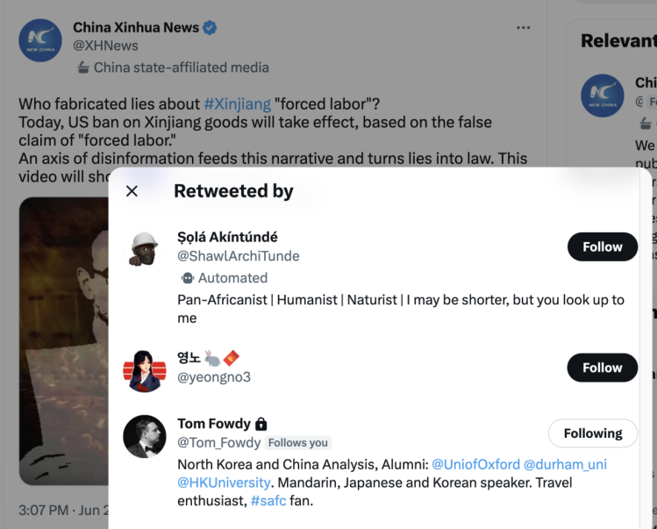
- 被海外大V转载情况
短片被今日俄罗斯资深记者Tom Fowdy转发
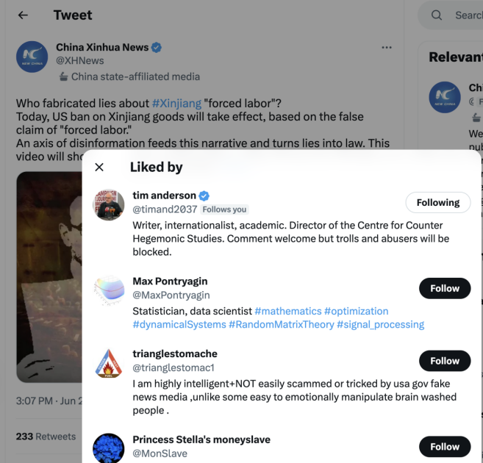
短片被澳大利亚学者Tim Anderson点赞
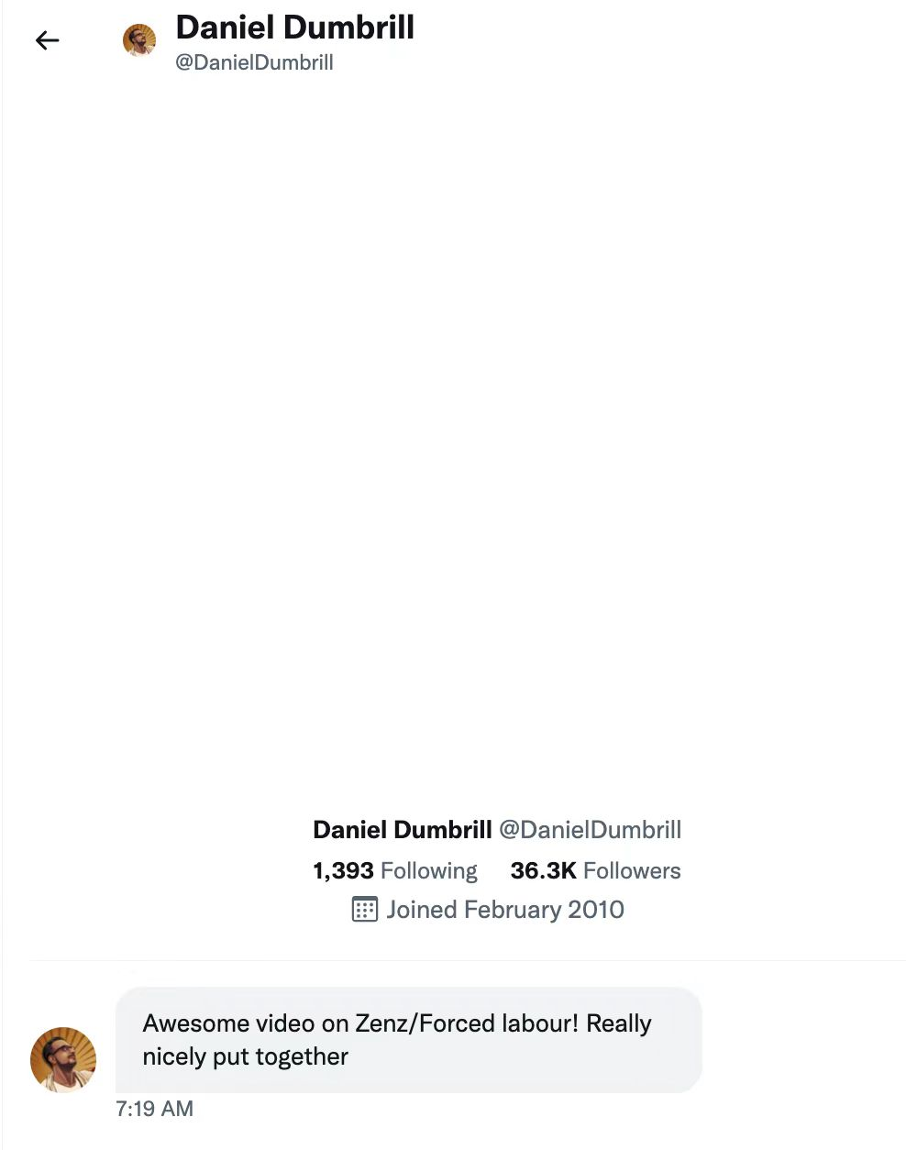
加拿大媒体人Daniel Dumbrill发送信息点赞短片

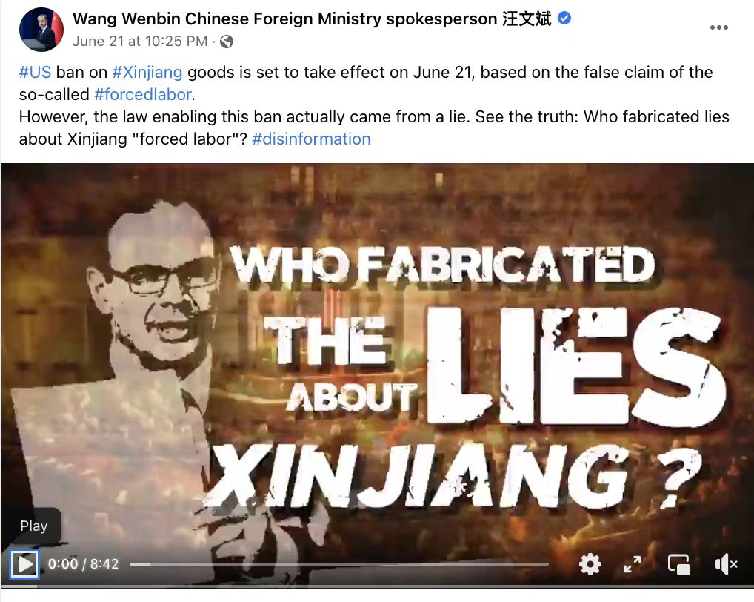
外交部发言人汪文斌转发短片

